Unit 8: East Asian Empires Test

Base your answer to the following question on the map below and on your knowledge of social studies

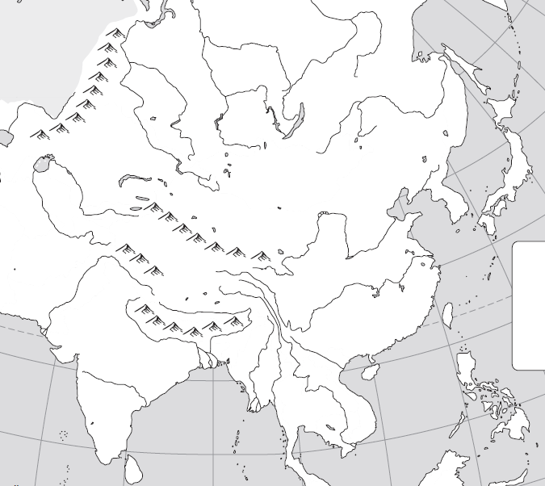
8
4
6
3
5
7
2
1

- Number 1 is called the
  - River valley
  - Western steppes
  - Taklimakan desert
  - Plateau

- Number 2 are the mountains that divide Europe and Asia
  - Himalayas
  - Appalachian
  - Ural
  - Andes

- Number 3 is a river called
  - Ganges
  - Chang Jiang
  - Yellow
  - Hunan

- Number 4 is a region that was the birth place of Genghis Khan
  - China
  - India
  - Mongolia
  - Russia

- Number 5 is a peninsula called
  - Korean
  - Arabian
  - Japanese
  - Indian

- Number 6 is a nation called
  - Japan
  - China
  - Mongolia
  - Korea

- Number 7 is a sea called
  - Sea of Japan
  - East China Sea
  - South China Sea
  - Arabian Sea

- Number 8 is a nation called
  - Japan
  - Mongolia
  - Korea
  - China

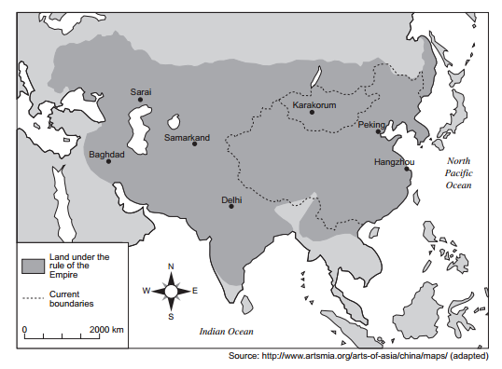

- Which empire does this map show?
  - Mongol
  - Songhai
  - Roman
  - Persian

- Which achievements are most closely associated with the Tang and Song dynasties of China?
- Wheel and stirrup
- Chinampas and calendar
- Calendar and moveable wooden type
- Mosaics and domes

- Korea has frequently served as a cultural bridge between
- Cambodia and Vietnam
- Russia and India
- Thailand and Indonesia
- China and Japan

- Which culture is credited with the development of gunpowder, the abacus, and the compass?
- Chinese
- Persian
- Indian
- Japanese

- Which geographic factor directly influenced the early interactions between China and Korea?
- location
- monsoons
- arid climate
- tropical savannas

- Which civilization first developed a civil service system and created silk?
- Aztec
- Chinese
- Japanese
- Roman

- Which belief system teaches that there are spirits in nature?
- Shinto
- Hinduism
- Judaism
- Islam

- The terms Bushido, samurai, and daimyo are most closely associated with which group in Japanese history?
- Emperors
- Warriors
- Peasants
- Merchants

- She was the only empress of China
- Wu Zhao
- Tang Taizou
- Borte
- Kublai Khan

- A chain or cluster of islands is called a(n)
- Atoll
- Ring of Fire
- Archipelago
- Peninsula

- This Japanese warrior was called a(n)
- Mongol
- Samurai
- Conquistador
- Crusader

- Unified the Mongols under his leadership around 1200
- Accepted the title of “universal ruler” of the Mongol clans
- Conquered much of Asia in two decades

- Who is the ruler described above?
- Temujin
- Borte
- Jamuka
- Kublai

Unit 8: East Asian Empires Test

Base your answer to the following question on the map below and on your knowledge of social studies

8
4
6
3
5
7
2
1

- Number 1 is called the
  - River valley
  - Western steppes
  - Taklimakan desert
  - Plateau

- Number 2 are the mountains that divide Europe and Asia
  - Himalayas
  - Appalachian
  - Ural
  - Andes

- Number 3 is a river called
  - Ganges
  - Chang Jiang
  - Yellow
  - Hunan

- Number 4 is a region that was the birth place of Genghis Khan
  - China
  - India
  - Mongolia
  - Russia

- Number 5 is a peninsula called
  - Korean
  - Arabian
  - Japanese
  - Indian

- Number 6 is a nation called
  - Japan
  - China
  - Mongolia
  - Korea

- Number 7 is a sea called
  - Sea of Japan
  - East China Sea
  - South China Sea
  - Arabian Sea

- Number 8 is a nation called
  - Japan
  - Mongolia
  - Korea
  - China

- Which empire does this map show?
- Mongol
- Songhai
- Roman
- Persian

- Which achievements are most closely associated with the Tang and Song dynasties of China?
- Wheel and stirrup
- Chinampas and calendar
- Calendar and moveable wooden type
- Mosaics and domes

- Korea has frequently served as a cultural bridge between
- Cambodia and Vietnam
- Russia and India
- Thailand and Indonesia
- China and Japan

- Which culture is credited with the development of gunpowder, the abacus, and the compass?
- Chinese
- Persian
- Indian
- Japanese

- Which geographic factor directly influenced the early interactions between China and Korea?
- location
- monsoons
- arid climate
- tropical savannas

- Which civilization first developed a civil service system and created silk?
- Aztec
- Chinese
- Japanese
- Roman

- Which belief system teaches that there are spirits in nature?
- Shinto
- Hinduism
- Judaism
- Islam

- The terms Bushido, samurai, and daimyo are most closely associated with which group in Japanese history?
- Emperors
- Warriors
- Peasants
- Merchants

- She was the only empress of China
- Wu Zhao
- Tang Taizou
- Borte
- Kublai Khan

- A chain or cluster of islands is called a(n)
- Atoll
- Ring of Fire
- Archipelago
- Peninsula

- A medieval Japanese warrior was called a(n)
- Mongol
- Samurai
- Conquistador
- Crusader

- Unified the Mongols under his leadership around 1200
- Accepted the title of “universal ruler” of the Mongol clans
- Conquered much of Asia in two decades

- Who is the ruler described above?
- Temujin
- Borte
- Jamuka
- Kublai

